Individual Assignment

Map:

Legend:

Puzzle:



Item:

User Manual:

All commands must be typed into the console.

“North”:

Typing this command will move the player North. If there is no room in that direction, the player will be alerted.

“West “:

Typing this command will move the player West. If there is no room in that direction, the player will be alerted.

“South”:

Typing this command will move the player South. If there is no room in that direction, the player will be alerted.

“East”:

Typing this command will move the player East. If there is no room in that direction, the player will be alerted.

“Explore”

Typing this command will allow the player to see if there are items in the room.

“Pick up”

Typing this command will allow the player to add item into their inventory. And remove said item from the room inventory.

“Drop”

Typing this command will allow the player to remove item from player inventory and add item into room inventory.

Game play screen shots at various stages of development:

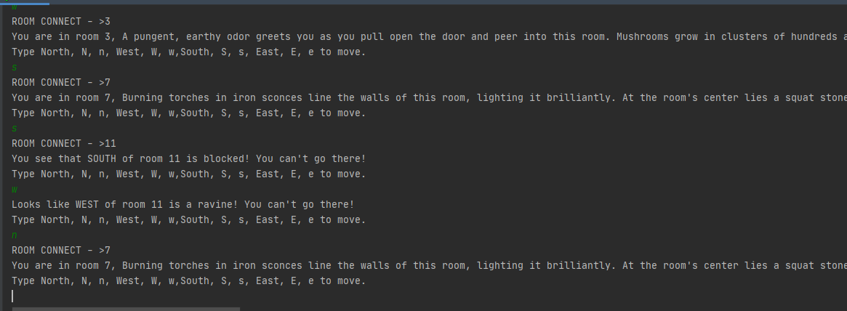

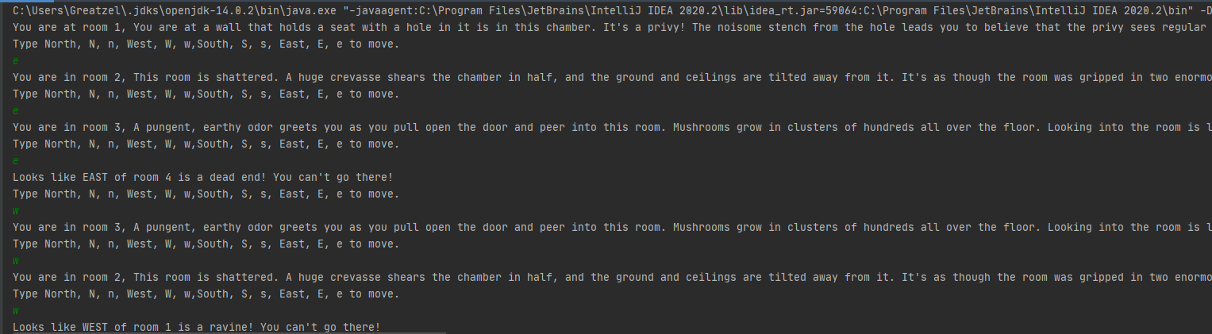

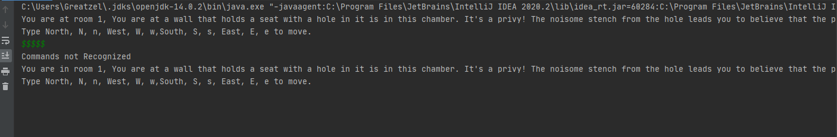

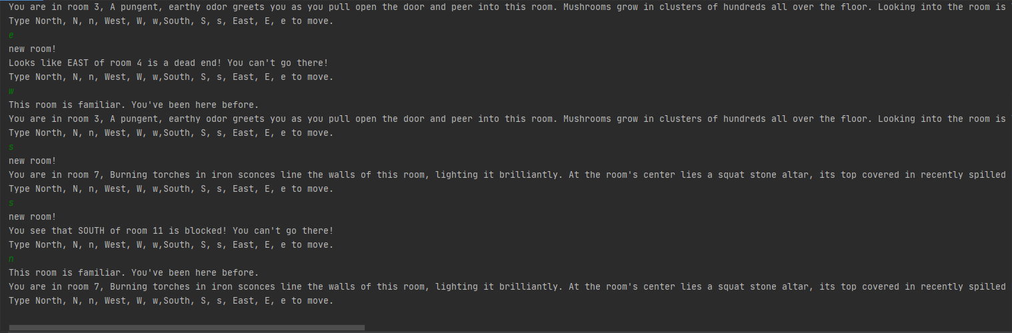

Individual Assignment 2 screenshots from various stages of development:

